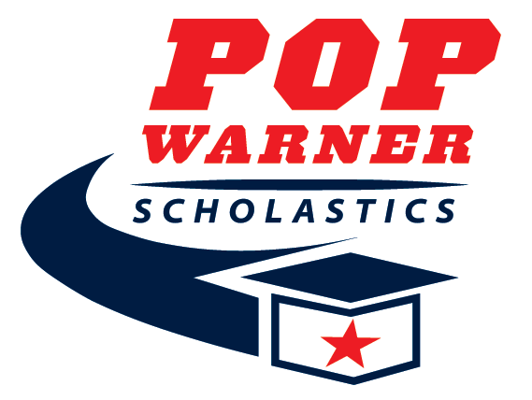
2026 Preschool Form
This form is strictly for athletes who are not of age to attend school and obtain a report card.

Participant Name: _______________________________________________________________

Address: ______________________________________________________________________

City: _____________________________________ State: ____________ Zip: ______________

Phone: (_______) ______-__________ Circle One: Football Spirit

Association: _____________________________________________ Level: _________________

Parent/Guardian Name: __________________________________________________________

I __________________________________ Parent/Guardian of said child named above state that he/she is scholastically fit to participate in the Pop Warner program for the 2026 season.

Parent/Guardian Signature: _________________________________ Date: _________________

